Task 1

The Star Path
Equipment: Work sheets with the stars.
Start at the small white star.
Then draw the fewest number of connected straight lines that will pass through each blue star and end on the big white one. You have to draw the lines without lifting the pen from the paper.
It is OK to let the lines cross each other,
and you can pass through a star more than once.

Answer Country:

Work Sheet Task 1

Task 2

Three coins
Equipment: Three 1 euro coins

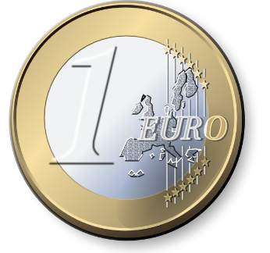

Joe to Jim: “I’m going to toss three 1 euro coins in the air 40 times.
If they all fall heads, I will give you 2 euro.
If they all fall tails, I will give you 2 euro.
But if they fall any other way, you have to give me 1 euro.”
Was it wise for Jim to accept the bet?
Give a reason for your answer.

Answer Country:

Task 3

Points at a ball
Equipment:
- A ball of Styrofoam
- Needles with colored heads
- Thread

What is the largest number of points that can be placed on a ball in such a way that every point is placed with the same distance to each other – when we measure the distance on the surface of the ball.
Show you solution on the ball. Use needles to represent points and
thread to represent lines.
The solution with the equipment does not have to be accurate,
so you have to give a short explanation of your idea.

Answer Country:

Task 4

The Monkey and the Coconuts
Three sailors are shipwrecked on an island and collect a large pile of coconuts during the day.
That night the first sailor wakes up and decides to take his first share early. He tries to divide the pile of coconuts equally into three piles, but finds that there is one coconut left over. He tosses the reminding coconut to a monkey and then hides "his" one of the three equally sized piles of coconuts. Then he pushes the other two piles together to form a single visible pile of coconuts again and goes to bed.
To cut a long story short, the two other sailors in turn gets up once during the night and perform the same actions of dividing the coconut pile into three, finding that one coconut is left over and giving that single remainder coconut to the monkey.
In the morning the remaining coconuts are divided into three equal piles for each of the sailors, whereupon it is found that the pile of coconuts divides equally amongst the sailors with no remainder. Nothing for the monkey in the morning.
Calculate the minimum possible size of the initial pile of coconuts collected during the first day.

Answer Country:

Task 5

Numbers with a spesific sum
Equipment: Work sheets with the numbers.
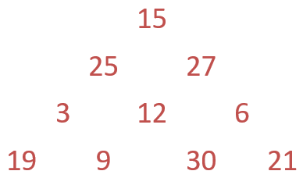
Study the numbers in the triangle.
The challenge is to find numbers with a specific sum.
Use as many numbers as you can for
each of the following sums: 50, 60, 66.
Mark the numbers with circles.

Answer Country:
SUM 50 | SUM 60 | SUM 66

Work Sheet Task 5

