Task 1

Largest possible area

Equipment: Pentomino-bricks and square grid paper

Use the Pentomino-bricks to frame/enclose the largest possible area.
Two neighbouring bricks must share at least one side.
The bricks can not be placed corner against corner. 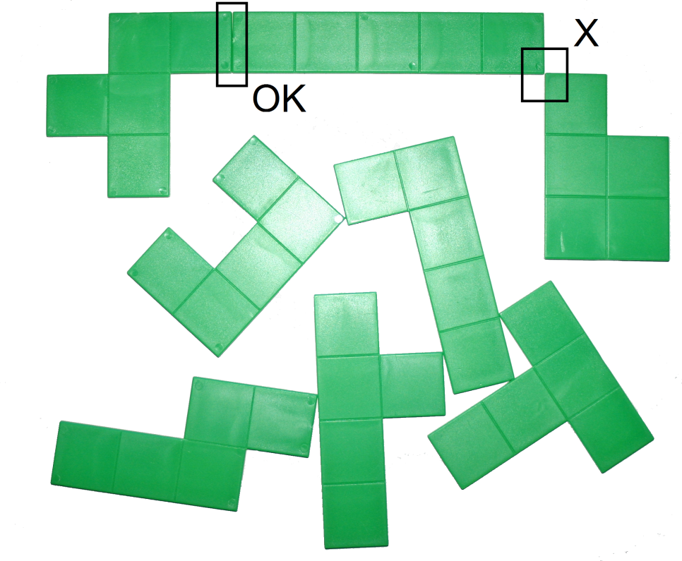

Find out how many unit squares the area consists of.
Leave the bricks on the grid paper.
Mark where the fence would be and show how you have calculated the area.

Task 2

Cubes with holes in

Equipment: A cube made of Multilink cubes

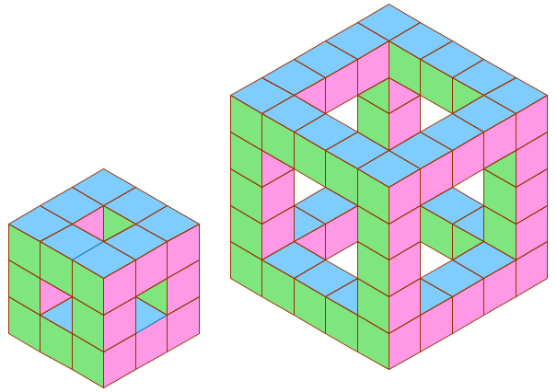
The picture shows the first and third of figures that can be made in infinitely many sizes.
Find a relation between the figure number and the number of small cubes required to make the figure. Present the relation in two different ways.
Express each of these relations algebraically.
Use the cube you have been given to explain the algebraic expression
you have found to the judges.
How many cubes are there in figure number 17?

Task 3

Bricks being rotated

Equipment: 7 bricks

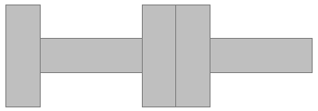All five bricks rotated 90º.

The seven bricks you have been given can be put next to each other either along their shortest or longest sides, as shown in the top figure with five bricks.
The bricks can all be rotated 90º as shown in the bottom figure.
Make a symmetrical pattern with 7 bricks. When you rotate all the bricks 90º you want to get a new symmetrical pattern that is 25 cm shorter that the original pattern.
Next rotate three of the bricks one more time.
Then you want to get a new symmetrical pattern that is 20 cm shorter than the original one you started with.
- What can be the length and breadth of each brick?
- Show on a drawing what the three patterns look like.

Task 4

The sum along the sides

Equipment: cards with values 1-9, paper with boxes for placing the cards in.

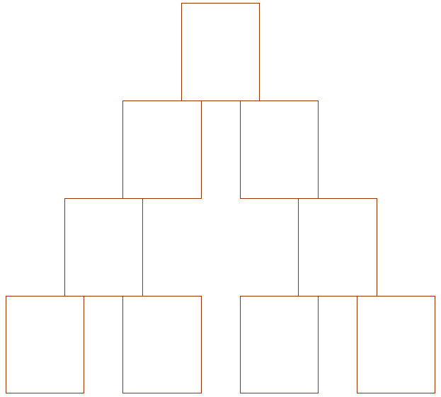

Place the nine cards in the boxes so that the sum along each of the three sides will be the same.
Find as many possible sums as you can.

Task 5

Square on a geoboard

Equipment: 2 geoboards 5 x 5. Calculator.
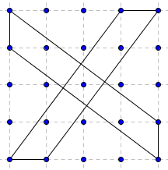

The two bands make a square that does NOT have corners in
the points of the geoboard.
- Make the largest possible square without corners
in the points of the geoboard.
- Find the area of the square measured in unit squares.

