NMCC 2013 – 2014
Nordic Math Class Competition
Nordic final

Problem 1

Ratios in Cross Flags

Equipment: Calculator

Example
Flags are often described by giving the ratios between its measurements.
The Danish flag – without hard-edge – has the ratio 6 : 2 : 9 (red : white : red)
on the longest side and 6 : 2 : 6 on the shortest side.

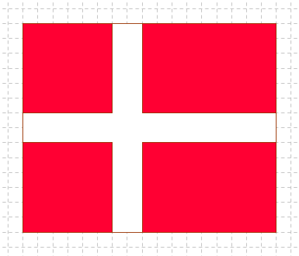

The ratio of the width to the height will then be 17 : 14 = 1,21.

Part 1
Find the ratio of the width to the height in the
Norwegian and the Icelandic flags.

[Part 1 should be completed (3 min) before part 2 is handed out (5-6 min)]
NMCC final 2014

Answer sheet problem 1, Part 1 Country: ___________

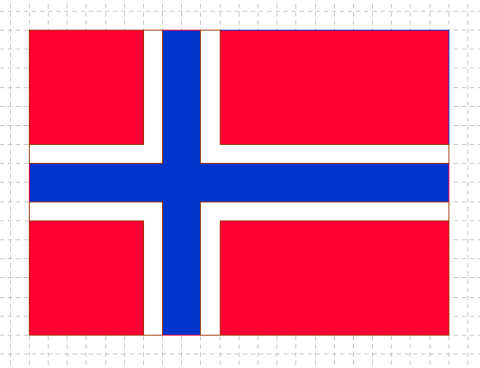

Ratio of width to height in the Norwegian flag: __________________________

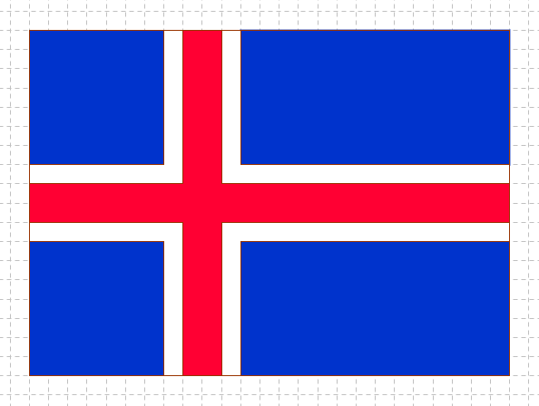

Ratio of width to height in the Icelandic flag: ____________________________

NMCC final 2014

Problem 1 Ratios in Cross Flags Part 2

The ratio of width to height in the Swedish flag is 16 : 10 = 1,6

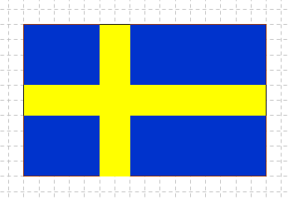

This ratio is close to the golden ratio which is 1,618.

- In a different Nordic country they have chosen two other numbers for the ratio so that it is about as close to 1,618, but not 1,6.
Which two other whole numbers give a ratio that is roughly as close to 1,618 as 16 : 10?

- What is the easiest approach to finding these two other numbers?

NMCC final 2014

Answer sheet Problem 1, Part 2

Country: _____________

NMCC 2013 – 2014
Nordic Math Class Competition
Nordic final

Problem 2

Nordic points

Equipment:
- Notes with the names of the 15 year olds
- Form for filling in the names of the students

Five 15 year olds have participated in a test.
We know that
- They got the scores 29, 30, 31, 32 and 33.
- Dan scored higher than 31.
- Finn did not get the highest or lowest score.
- Isa´s score was an even number
- Nora´s score was divisible by three.
- Sveas score was a prime number

Find all possible solutions for the students´ scores.
NMCC final 2014

Work sheet, problem 2

Score | Name
29
30
31
32
33

NMCC final 2014

Notes with the names of the 15 year olds

Dan | Dan | Dan
Finn | Finn | Finn
Isa | Isa | Isa
Nora | Nora | Nora
Svea | Svea | Svea
Dan | Dan | Dan
Finn | Finn | Finn
Isa | Isa | Isa
Nora | Nora | Nora
Svea | Svea | Svea

NMCC final 2014

Answer sheet, problem 2 Country: ________________

Score | Name | Name | Name
29
30
31
32
33

NMCC 2013 – 2014
Nordic Math Class Competition
Nordic final

Problem 3

Sharing books

Equipment: 6 ”books” in A6-format

Ari and Sasja have six different books.
They are supposed to share them so that they both get an odd number of books.

In how many ways can they do this? Justify your answer.
Different books counts as different ways.

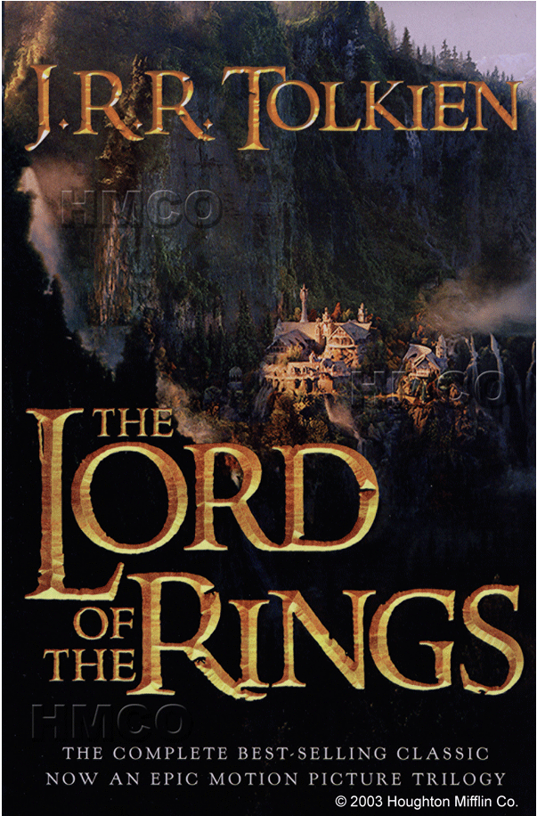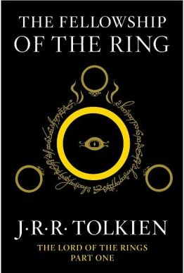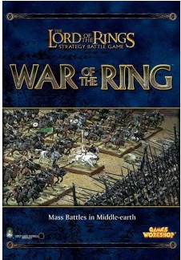

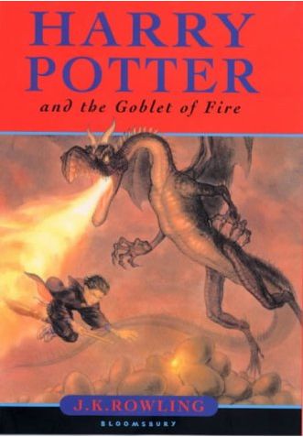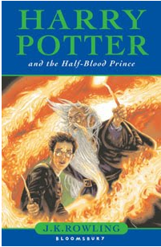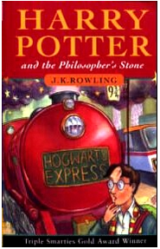

NMCC final 2014

Answer sheet, problem 3 Country: ________________

NMCC 2013 – 2014
Nordic Math Class Competition
Nordic final

Problem 4

The ant on the prism

Equipment: A rectangular prism

An ant crawls all the way around along one of the edges of a face of a rectangular prism. The distance crawled by the ant is 34 cm. Had the ant chosen one of the other faces, the distance would have been 26 cm or 40 cm.

What is the volume of the prism?

Answer problem 4 Country: ____________________

NMCC 2012 – 2013
Nordic Math Class Competition
Nordic final

Problem 5

Packing rectangles close!

Equipment:
- Eight rectangles with sides s and 2s where s takes values 1-8.
- A board with a grid of squares of side s.

You should place the eight rectangles on the grid so that they do not overlap.
When the rectangles have been placed on the grid you should draw four straight lines (forming a rectangle) that frames all your rectangles.
This framing rectangle will have a bigger area than
the eight rectangles together.

Example:
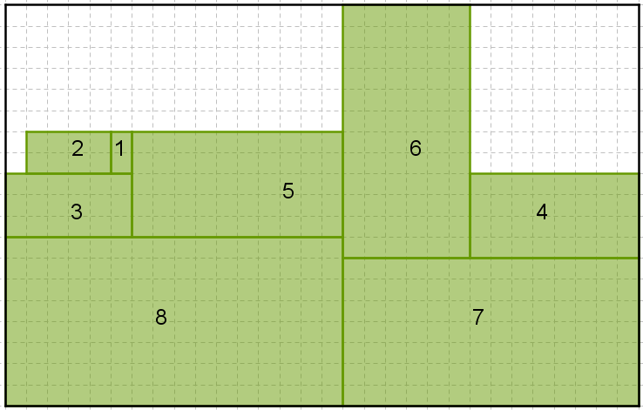

The challenge is to place the eight rectangles so that the framing rectangle becomes as small as possible.

Draw your solution on the answer sheet.
NMCC final 2014

Answer sheet, problem 5 Country: ________________

NMCC 2013 – 2014
Nordic Math Class Competition
Nordisk finale

Extra problem

Largest possible product

Equipment: calculator

Make two numbers with the digits 3, 4, 5, 6, 7, 8, 9.
Each digit can be used only once.

Multiply the numbers. The aim is to find the largest possible product.

After the first team has submitted their answer, the second team must submit their answer within one minute.

If both teams have the same answer, the team that delivers first wins.

Max time: 5 minutes.

Answer Extra problem Country: ________________

=

