NMCC 2011 – 2012
Nordic Math Class Competition
Nordic final

Problem 1

Balance with weights

A shopkeeper has an old-fashioned balance scale with three different weights. Each weight weighs a whole number of kilograms.

With these three weights he can measure all weights from 1 to 13 kilograms.

What are the masses of these three weights?

How can he use the weights to weigh from 1 to 13 kilograms?

If the shopkeeper gets a fourth weight,
he can measure all weights from 1 to 40 kg.

What is the mass of the fourth weight?
Explain your answer.
NMCC finale 2012

Answer sheet, problem 1 Country: _________________

Mass | Left side | Right side
1
2
3
4
5
6
7
8
9
10
11
12
13

The fourth weight must weigh _______ kilograms

Reason:

NMCC 2011 – 2012
Nordic Math Class Competition
Nordic final

Problem 2

Points between quarter circle and square

Equipment:
- Coordinate grid, 1st quadrant
- Compass and ruler

A circle with radius a has center (0,0). a is a whole number.
A square has a corner at (0,0) and the three others at (0,a), (a,0) and (a,a).

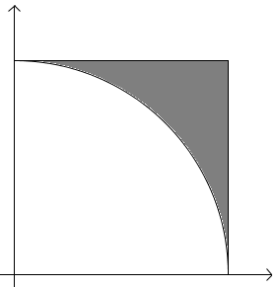In the area which lies between the square and the quarter circle (the black area) there can be points with whole number coordinates.

How large is a when there are exactly three points in this area?

Show your solution on the coordinate grid and write the coordinates of the points.

NOTE: The points must not lie ON the quarter circle or on the sides of the square.

NMCC final 2012

Answer sheet, problem 2 Country: ________________

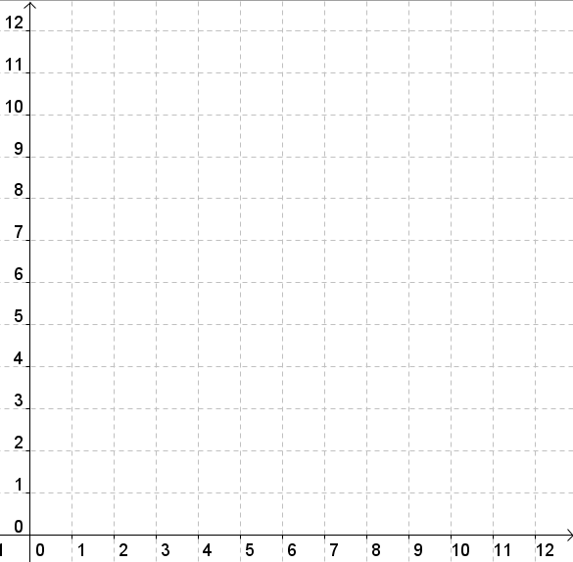

Coordinates of the points:

NMCC 2011 – 2012
Nordic Math Class Competition
Nordic final

Problem 3

Hexagon pattern

Equipment:
- Hexagon tiles
- Isometric paper

This picture shows the first two figures in a pattern that can grow indefinitely. The pattern is made of hexagons.

Figure 1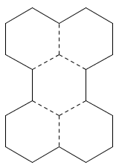 Figure 2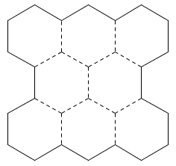

The perimeter of Figure 1 is 18.

What are the perimeters of Figures 2, 3 and 4?

Write a general rule for the relationship between the figure number and the perimeter.
NMCC final 2012 Isometric paper
NMCC final 2012

Answer sheet, problem 2 Country: ________________

Perimeter of

Figure 2: ______________________

Figure 3: ______________________

Figure 4: ______________________

General rule:
NMCC 2011 – 2012
Nordic Math Class Competition
Nordic final

Problem 4

Quadrilaterals on a 3 x 3 grid

Equipment:
- Two geoboards divided into nine regions with 3x3 points

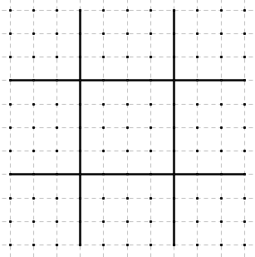On the geoboard you can see squares of 3x3 points.
Create quadrilaterals with their corners on the points.
Make as many different quadrilaterals as you can.
Two quadrilaterals count as the same if they are congruent.

Example of “quadrilaterals” which are not allowed.
The figure to the left is a triangle on the Geoboard.

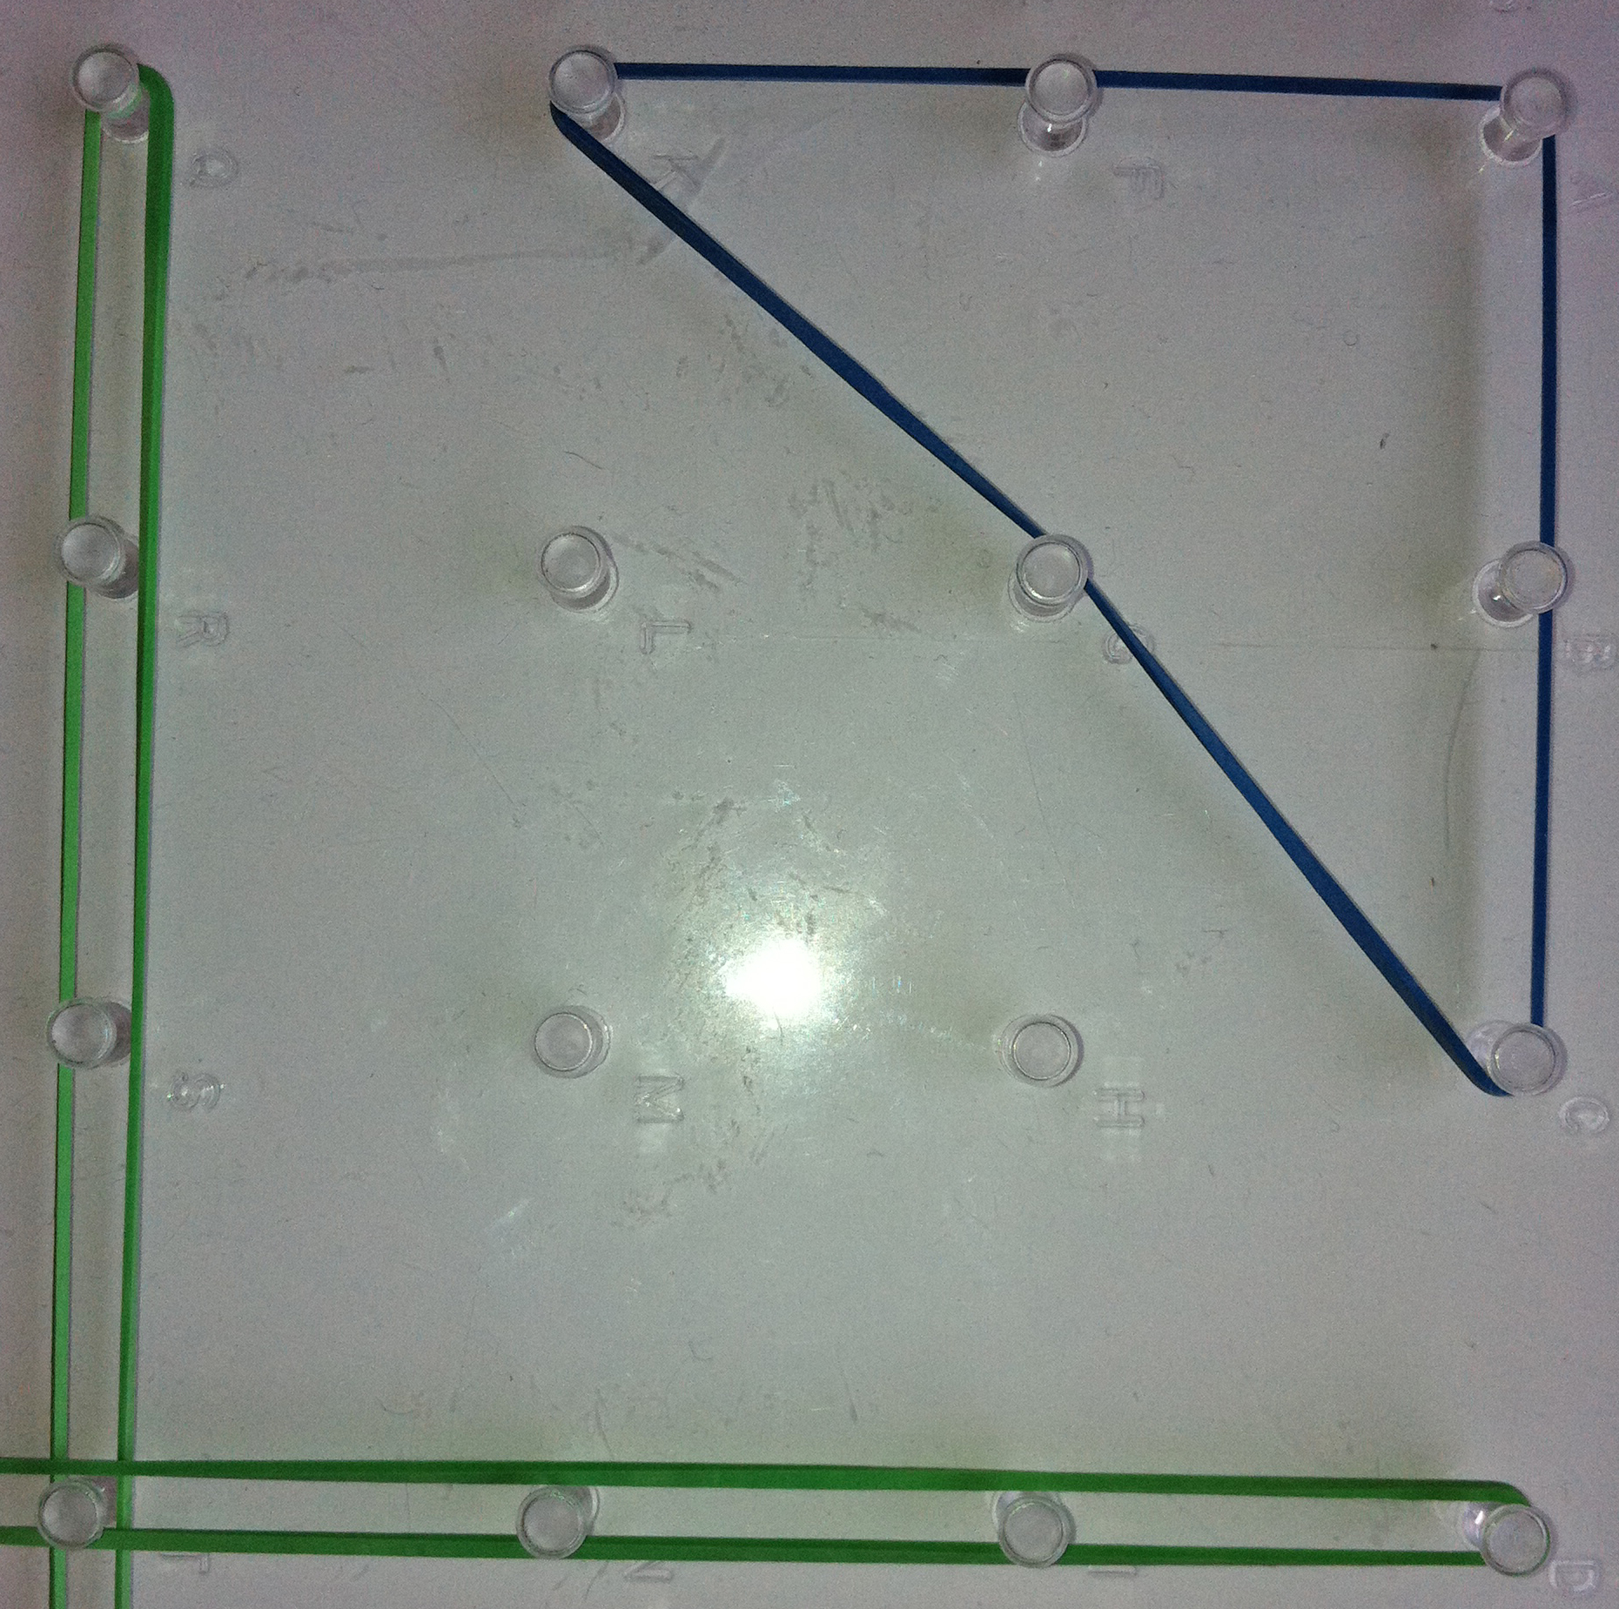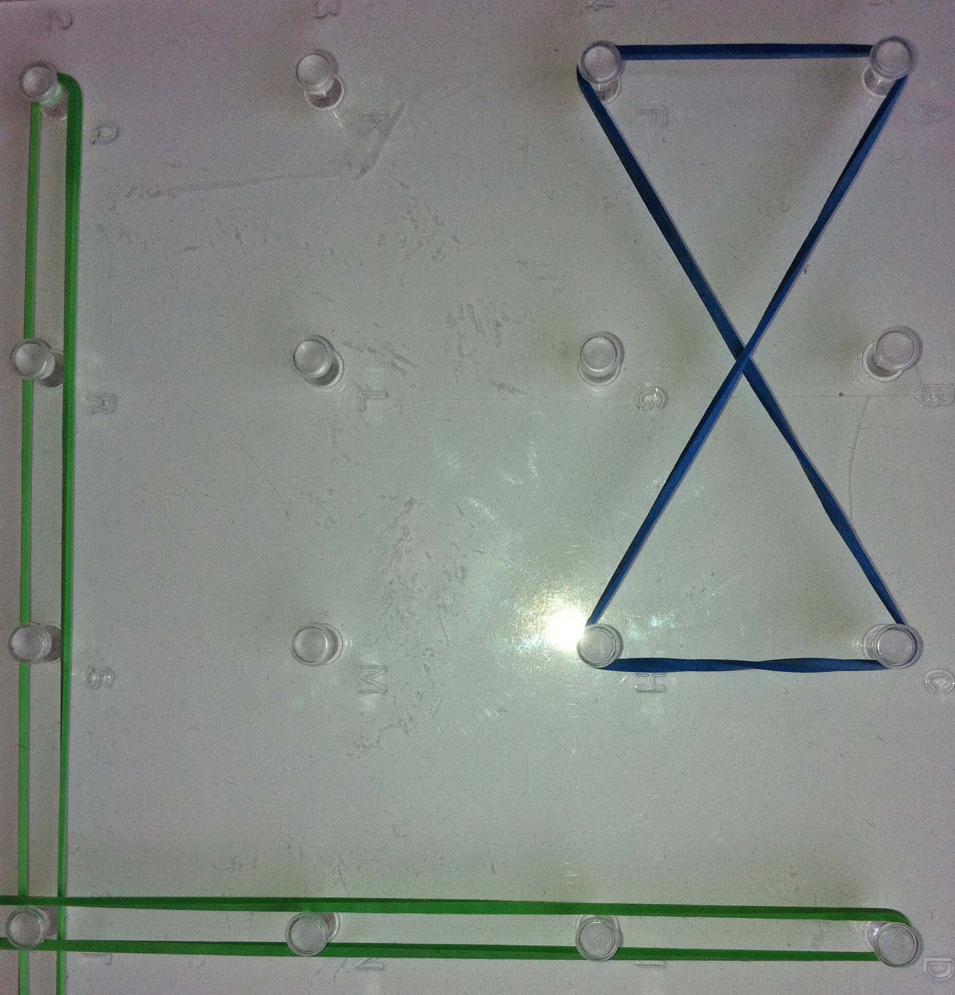

Deliver your answer on the geoboards.

NMCC 2011 – 2012
Nordic Math Class Competition
Nordic final

Problem 5

Addition puzzle

Equipment:
- Cards with values 1-9

Place cards in three columns and three rows to make three 3-digit numbers. The number in the lowest row must be the sum of the numbers in the two upper rows.

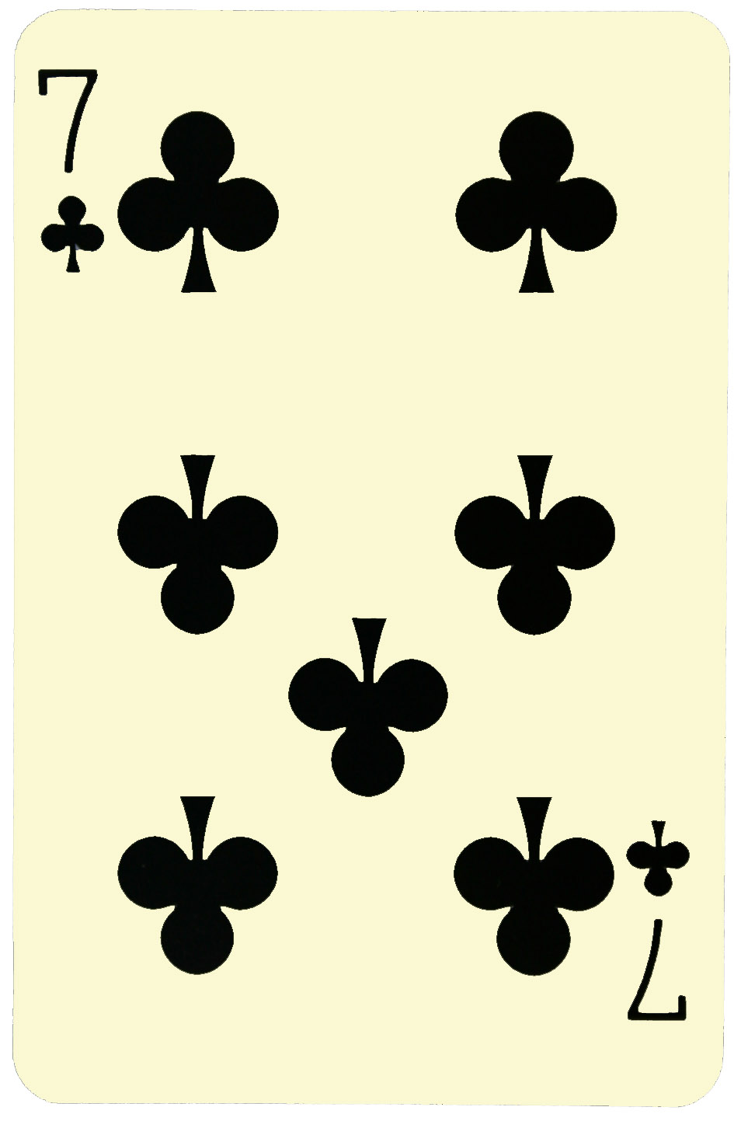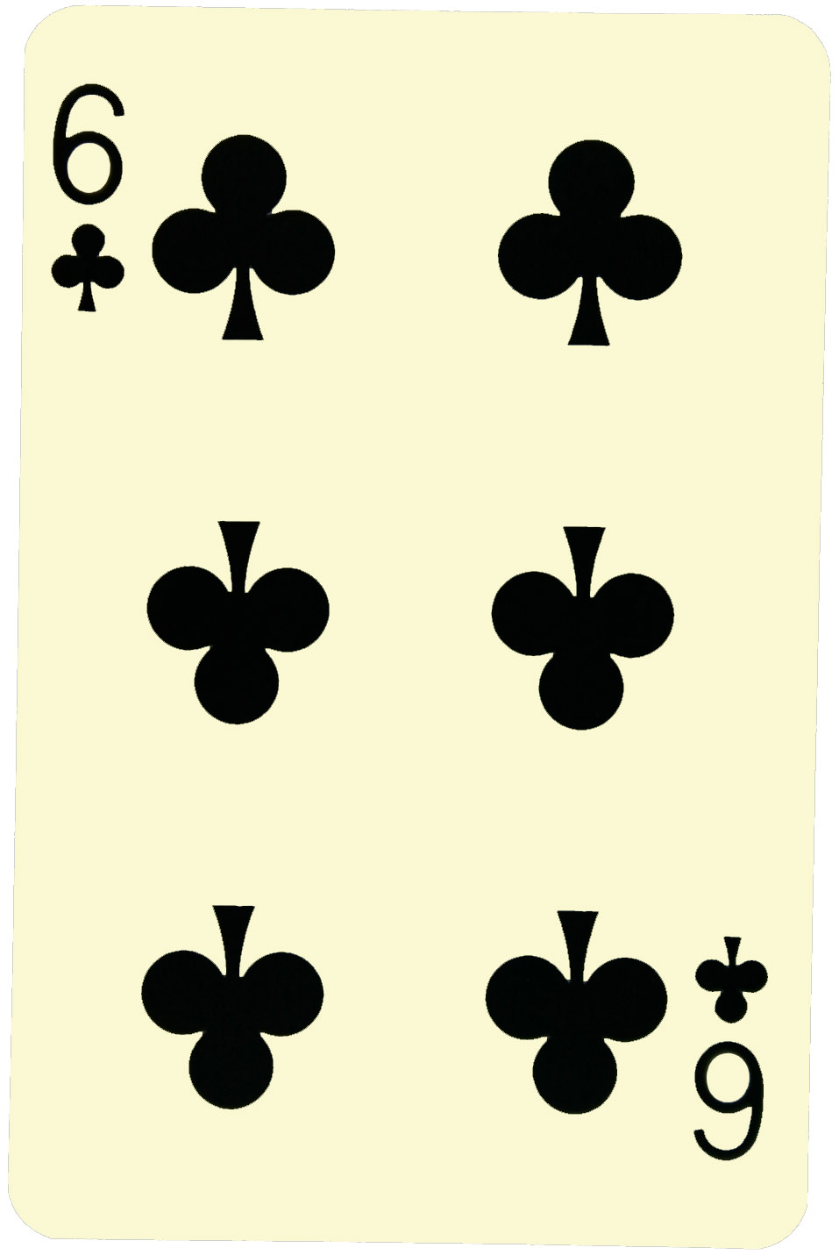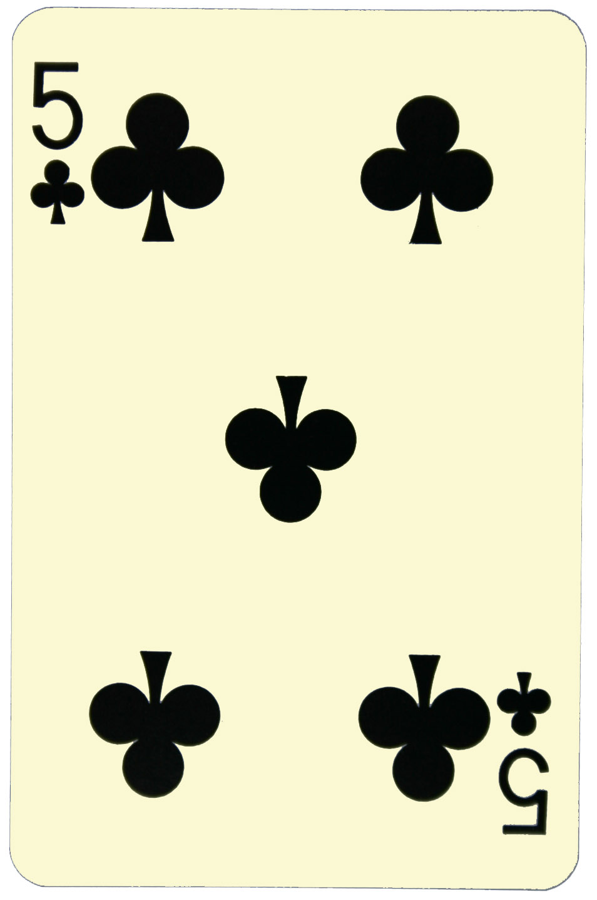
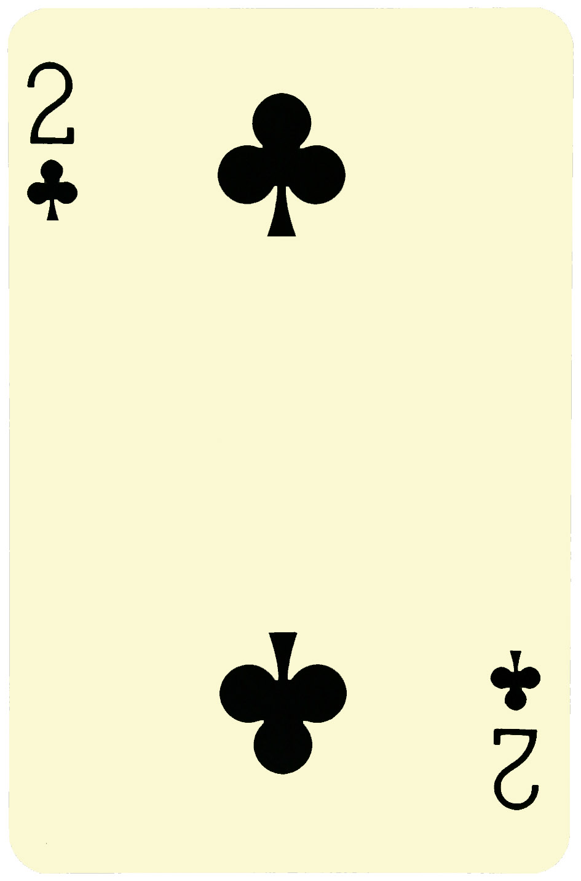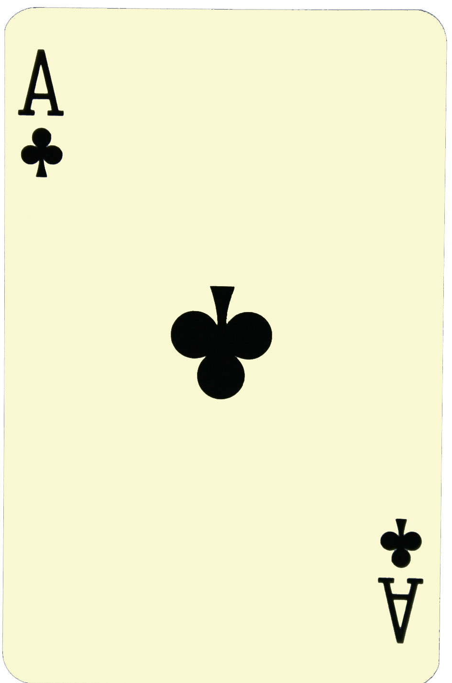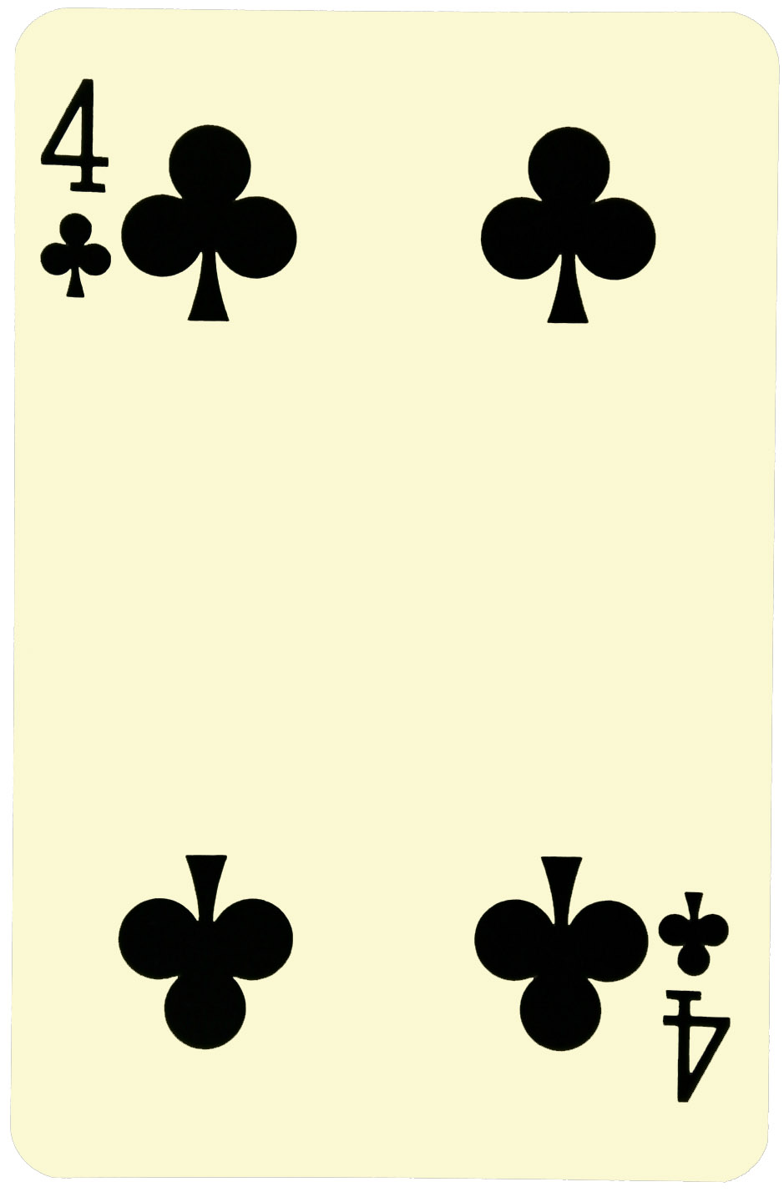
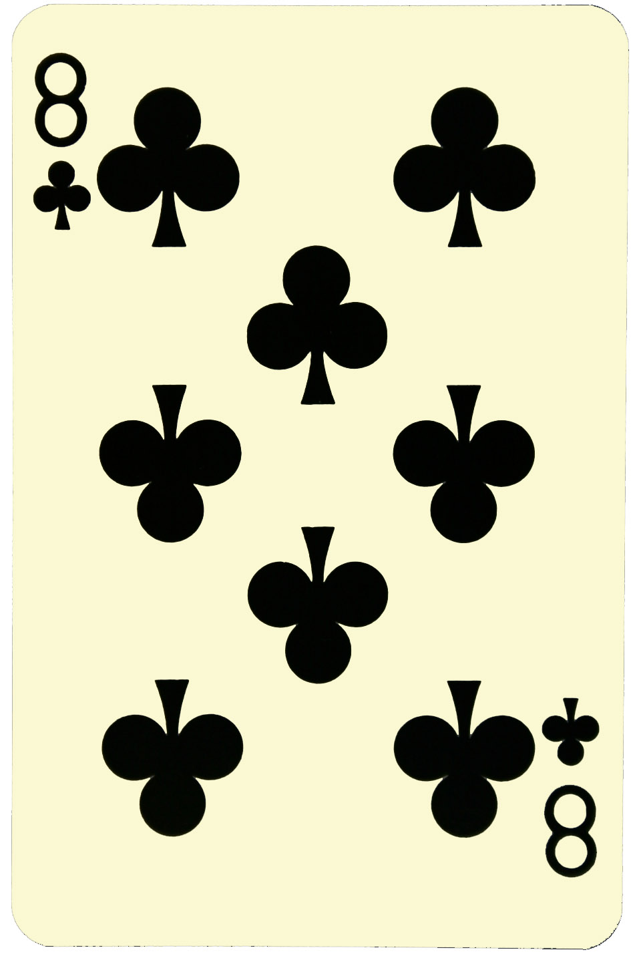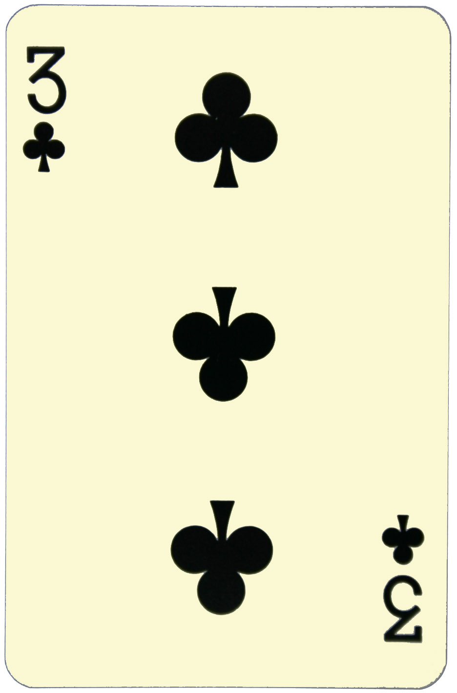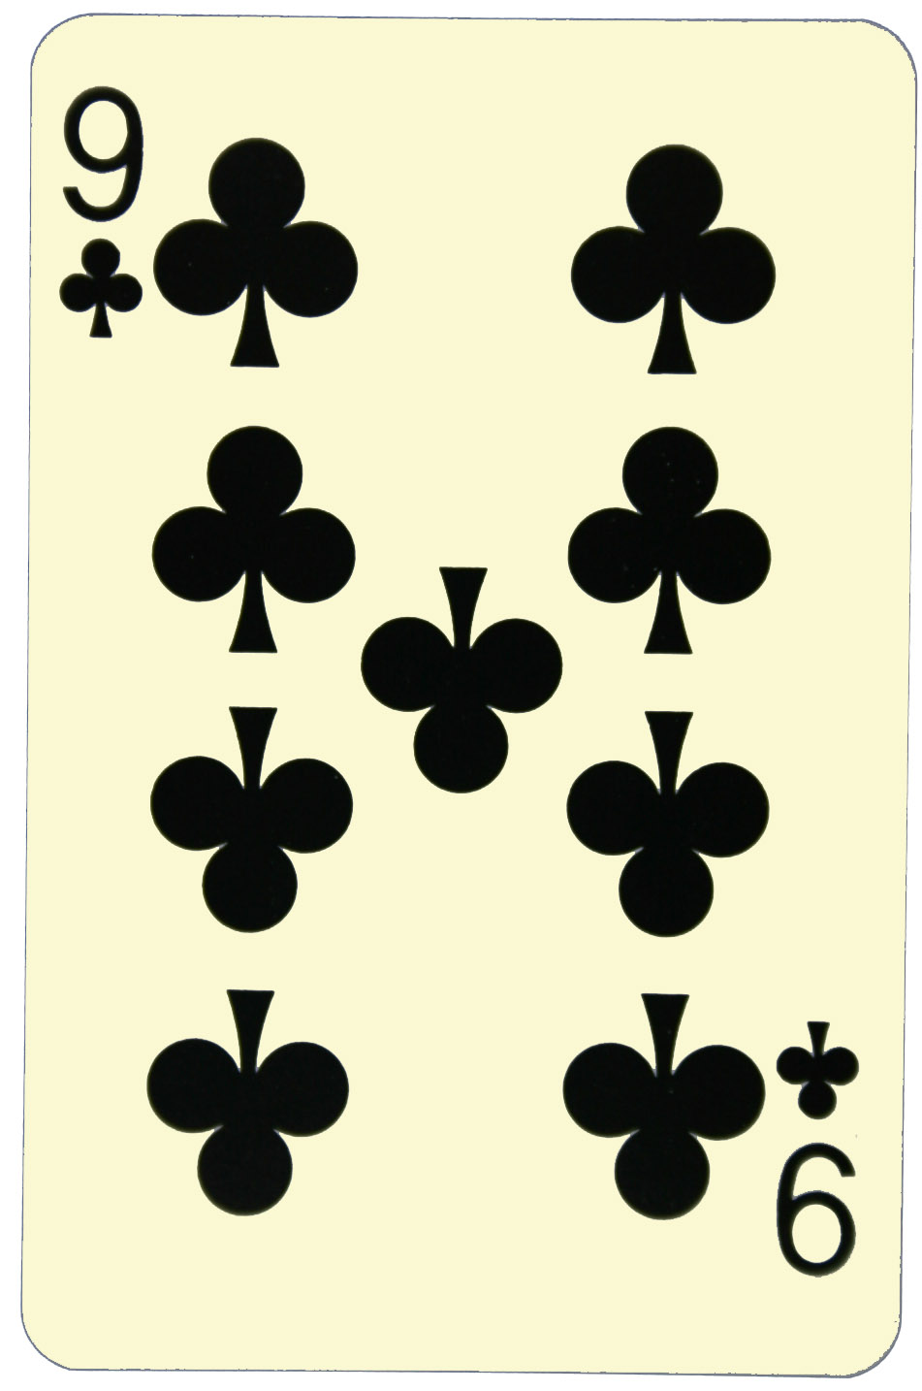
(But this is not correct!)
Write all the possibilities you find.
Since a + b = b + a this will be the same solution.
NMCC final 2012

Answer sheet, problem 5 Country: ________________

NMCC final 2012 Problem 5 Country: ________________

