Task 1

Isometric areas
Equipment:
- Work sheet 1 with parallelograms drawn in, 2 sheets.
- Work sheet 2 with trapezoids drawn in, 2 sheets
- Answer sheet
Investigate the areas of parallelograms and trapezoids drawn on the isometric (triangular) grid paper. The length of a triangle is 1.
The area of the figures is measured in number of triangles.
The side lengths of the figures you investigate should be whole numbers.
Example
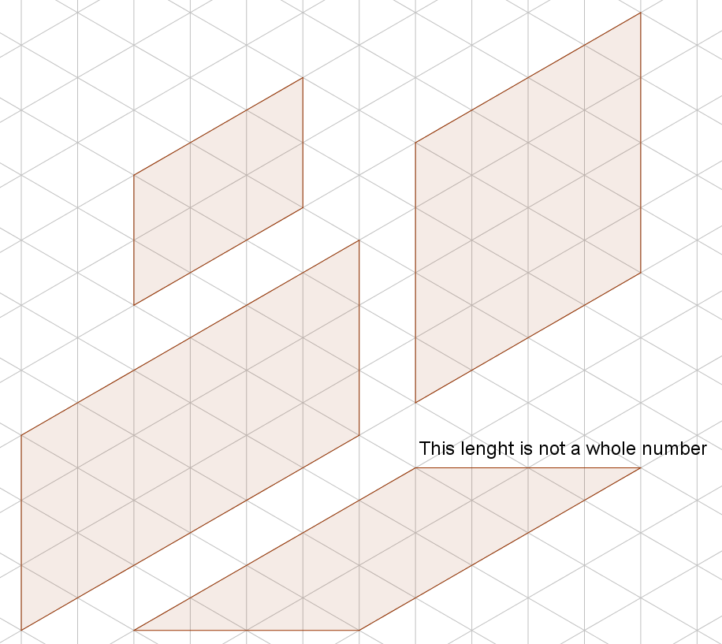
- Find the number of triangles in each parallelogram on work sheet 1. Compare the number of triangles with the side lengths of the figures.
- Find the number of triangles in each trapezoid on work sheet 2. Find the relation between the number of triangles and the side lengths of the trapezoids.

Task 1

Answer Sheet Country: _______________________________
Write the number of triangles in the figures
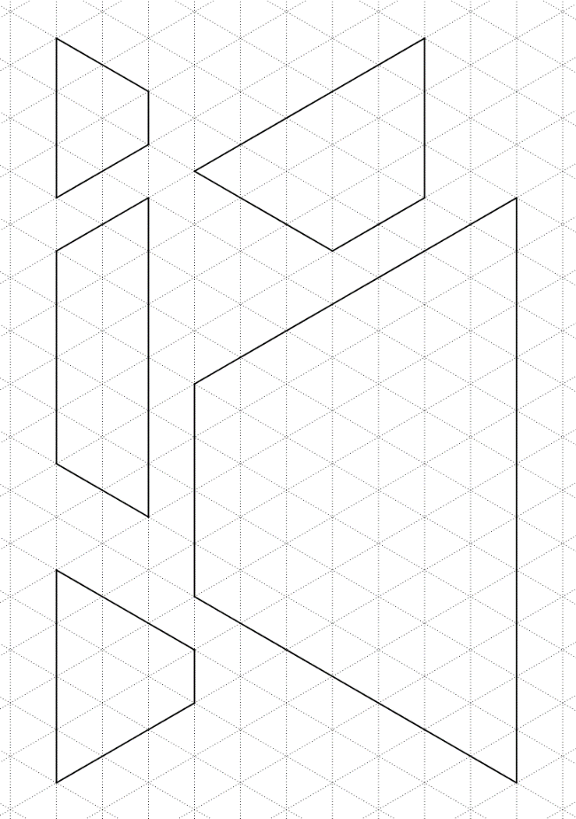
a) b)
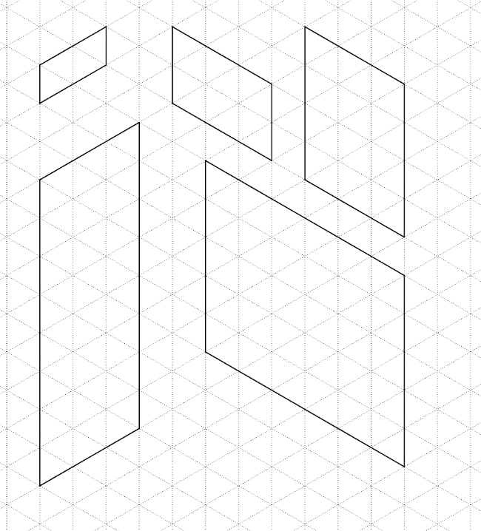

Compare the number of triangles with the lengths of the sides
a)

b)

Task 2

Arithmagons
Equipment: Work sheet with empty arithmagons.

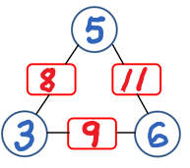
In an arithmagon the sum of two vertex-numbers should equal the number between the two vertices.
Find the numbers of the vertices of the two arithmagons below.

Answer Country:

a) b)
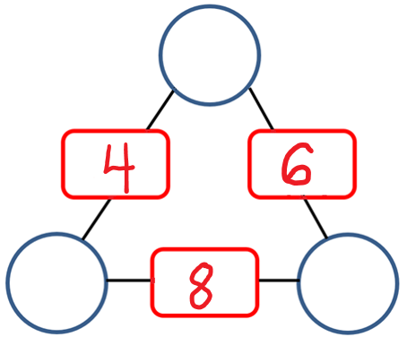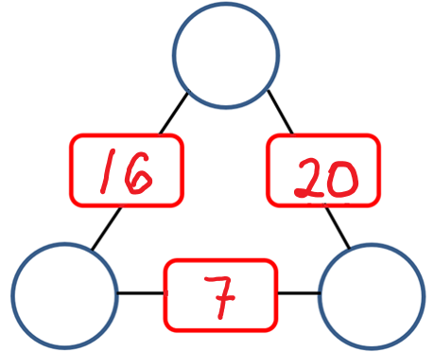

Task 3

Rectangles of pentomino-bricks
Equipment: Four sets of pentomino-bricks in four different colours.

Pentomino-bricks consist of five squares.
There are 12 different kinds of pentomino-bricks.
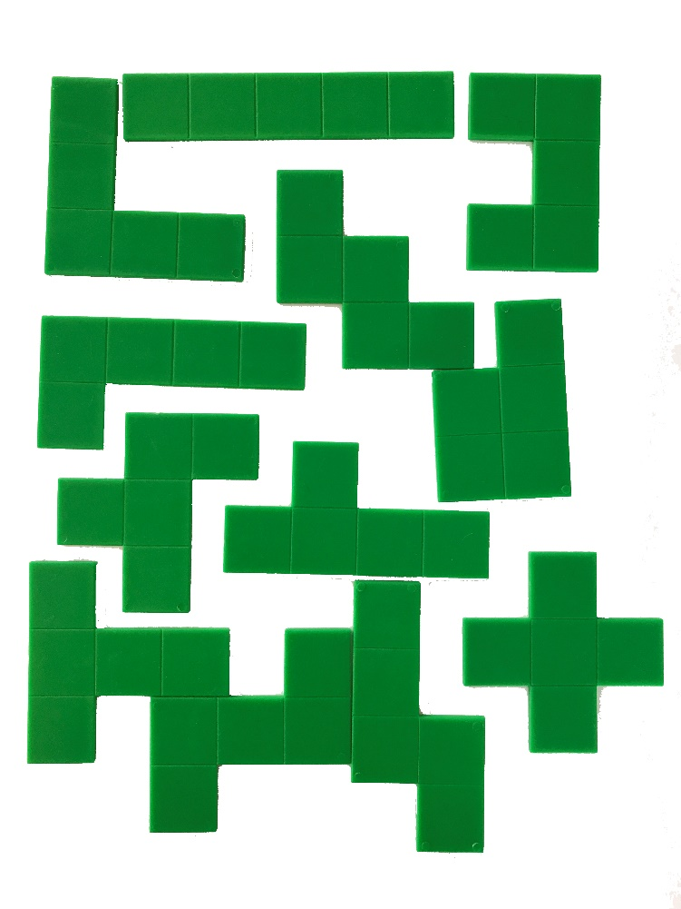
Use the pentomino-bricks to make up to four rectangles with different areas.
For each rectangle you should use at least three bricks from the same set.
The rectangles should not have any holes in them.
Leave the rectangles you make on the table.

Task 4

A strange bank account
In Nordic Bank it is only possible to insert 6 € or withdraw 11 € every time you go to the bank.
Example
Alice first inserts 6 €, then another 6 €, and yet another 6 €.
Next time she withdraws 11 €.
She then has 7 € on the account.
Now you have to investigate
- Which other amounts is it possible for Alice to have in her account?

- Which amounts could Alice have in an account where it is only possible to insert 6 € and to withdraw 14 €?

Answer Country:
a)

b)

Task 5

Remove the middle third
If we remove the middle third of a line segment with end points 0 and 1, we get two new line segments.
One line segment has end points 0 and ⅓, and the other has end points ⅔ and 1.
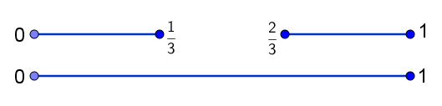
Imagine that we now continue to remove the middle third of the new line segments and that we repeat this process several times.
- Circle the fractions that will be end points of a line segment if the process is repeated enough times.
$\frac{11}{18}$ $\frac{8}{27}$ $\frac{61}{81}$ $\frac{15}{27}$ $\frac{77}{81}$ $\frac{2}{9}$
- Find a fraction with denominator between 100 and 300 and numerator between 150 and 210, which will be an end point of a line segment.

Answer Country:
- $\frac{11}{18}$ $\frac{8}{27}$ $\frac{61}{81}$ $\frac{15}{27}$ $\frac{77}{81}$ $\frac{2}{9}$

b)

