Task 1

Palindrom Numbers with deep greater than 1

Palindrom numbers are «symmetric» numbers. If we read the numbers from right to left we get the same number as if we were reading from left to right.
Examples: 77, 121, 22022022
1234 is not a palindrom number. But if we make a new number by reversing the order and then add the two numbers, we get a palindrom number: 1234 + 4321 = 5555.
We then define 1234 as a “palindrom number of deep 1”.
91 is a “palindrom number of deep 2”:
91 + 19 = 110. Since 110 is not a palindrom number we continue with the sum: 110 + 011 = 121.
After reversing two times the sum is a palindrom number.
We then define 91 as a “palindrom number of deep 2”.
97 is a “palindrom number of deep 6”!
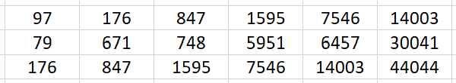
Find two-digit numbers of deep greater than 1.
Number | Deep | Number | Deep | Number | Deep | Number | Deep

Task 2

Unfolded Cube

Equipment: Work sheet
There is a letter at each side of a cube
The pictures show how the letters are placed.
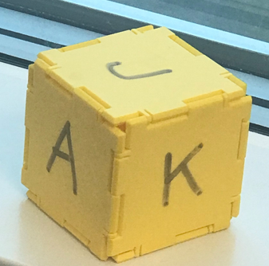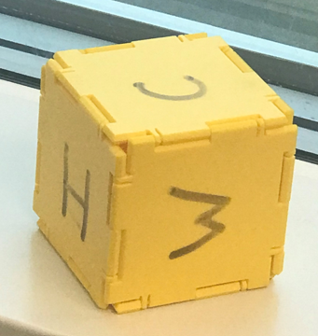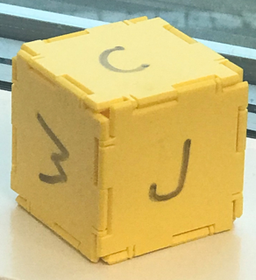

The figure under shows the cube unfolded with the A located in one of the squares.
Locate the other five letters in the squares with the shown orientation.

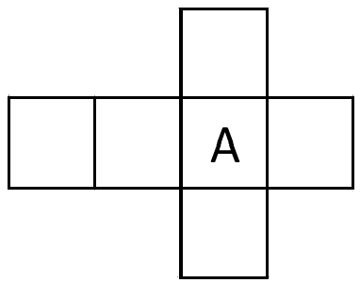

Work Sheet Task 2

Task 3

Scale up the figure

Equipment: Sheet with gridlines

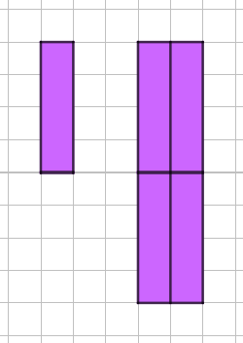 Figure 1 | An I is made of four squares.  If we use four I’s, we can build a bigger I in scale 2 : 1.  See Figure 1.

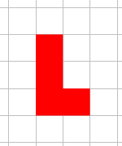Figure 2 | The letter L is made as shown at Figure 2.  - It is possible to scale up the L by putting together L’s.  - In which scales is it possible to make bigger L’s?

Answer
- Show examples at a sheet with gridlines.
b)

Task 4

How many crosses?

Equipment: Work Sheets Task 4a and Task 4b
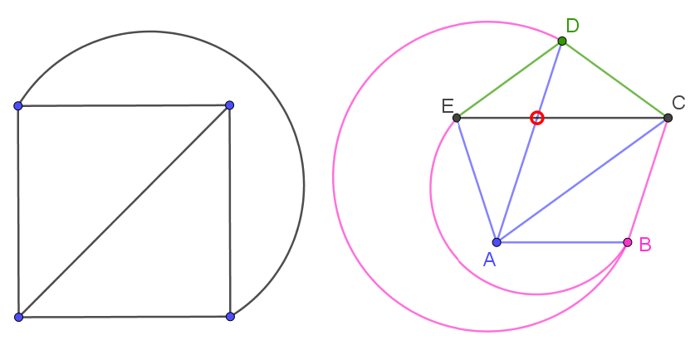
It is possible to combine four points with lines without any lines crossing each other.
If we try to combine five points with lines, we can’t avoid two lines to cross.

- Combine six points with lines in such a way that you get as few crossings as possible.
- The same challenge with seven points.

Answer Country:

Work Sheet Task 4a

Work Sheet Task 4b

Task 5

Domino Train

Equipment: 45 Domino pieces

You have 45 domino pieces with all possible combinations of the numbers 0-8.
The goal is to make a «train» as long as possible in such a way that the product of the two numbers that are put together is an even number greater than 5 and less than 39. The number in the ends is not used in any multiplication.

Example
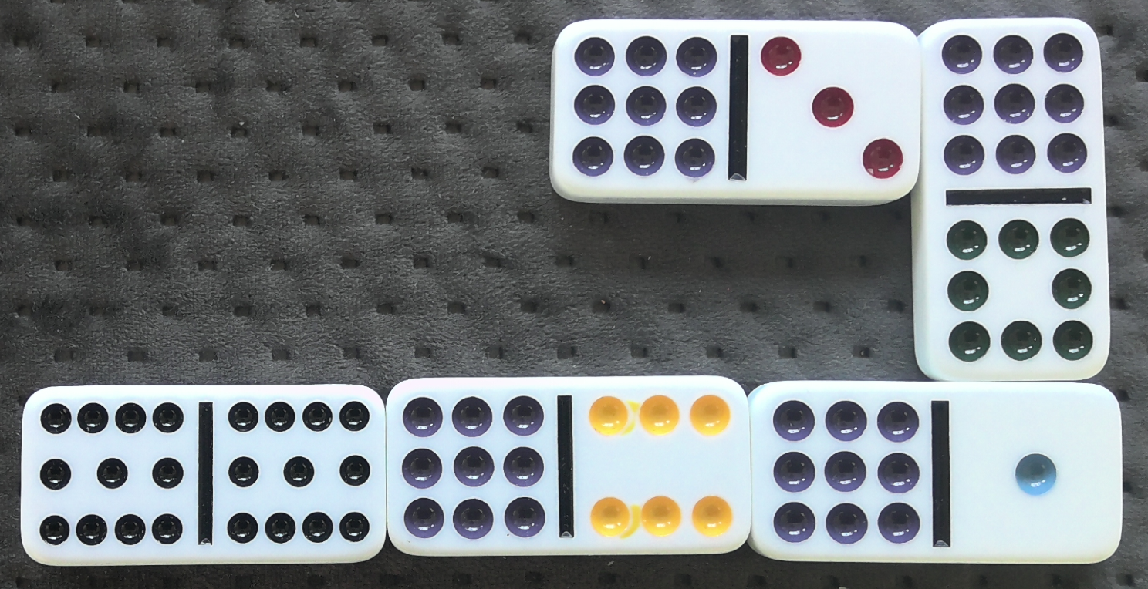
11 x 9 = 99 6 x 9 = 54

Leave your train at the desk.

